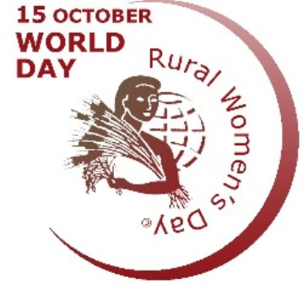


Press Release

Civil society urges to take the best possible steps to protect women in disaster
Press Conference to Celebrate International Rural Women's Day

Dhaka, 14 October 2024. Civil society has called for urgent action to protect women during disasters, emphasizing their right to physical, mental and reproductive healthcare and security. Women often face significant long-term physical and emotional harm due to the lack of awareness, sensitization and inadequate emergency services. Rights-based civil society representatives urged that the protection of women must be a key consideration in all disaster relief and service delivery efforts.

This appeal was made during a virtual press conference organized by the National Committee for the Observation of International Rural Women's Day. Speakers highlighted the physical, financial and emotional pressure on women during and after disasters, which often goes undervalued. They stressed the need for women-friendly and inclusive initiatives, designed with the collaboration of both government and non-government agencies, to address the challenges women face during and after such events.

Khadijatul Kubra, Program Officer, COAST Foundation, presented the keynote. The event was chaired by Shamima Akhtar, Chairperson of the National Committee for International Rural Women's Day Observation and moderated by Ferdous Ara Rumee, the Secretariat Coordinator of the committee. Other committee members, including Mothura Tripura (Khagrachari), Tofazzal Sohel (Hobiganj), Sayed (Bogra), Md. Khalilur Rahman (Jhalokathi), Aynun Nahar (Mymensingh), Rotna Borman (Khulna), Firoza Begum (Lalmonirhat), Jafrul Alam (Chapainawabganj), Swarna (BNNRC), Mustafa Kamal Akand and others, also shared their insights at the event.

In her keynote, Khadijatul Kubra stated that over 5.1 million people have been affected by floods in the eastern region this year. During disasters, low-income and marginalized communities suffer the most, particularly women and children. Women often spend nights on rooftops or in boats to protect their belongings and livestock, while children fall ill due to wet clothes.

Women, especially during their menstrual period, struggle to maintain hygiene due to a lack of clean water and sanitary items. Pregnant women are also at significant risk, as reproductive health services remain inadequate during these difficult times. The conditions in shelters, characterized by overcrowding, lack of separate toilets for women and insufficient clean water, heighten the stress on women and undermine their safety and dignity.

Mothura Tripura pointed out that the abortion rate in the eastern regions has risen due to the stress of floods, asset loss, malnutrition and inadequate care. She urged the provision of emergency reproductive services for pregnant women during disasters. Feroza Begum noted that there are no integrated services (physical, mental, reproductive health and others) for women post-disaster. Tofazzal Sohel emphasized the need for mental health services for women to address trauma and stress. Aynun Nahar underscored the importance of menstrual health awareness and the proper use and disposal of sanitary products during disasters.

Ferdous Ara Rumee highlighted that disaster situations are particularly dangerous for pregnant women and stressed the need for comprehensive awareness programs on reproductive health in collaboration with local communities and health workers. Shamima Akhtar called on the government to adopt and implement effective programs to protect women’s health during disasters.

On behalf of the organizers, Mustafa Kamal Akand noted that International Rural Women's Day is celebrated across over 50 districts in Bangladesh through rallies, seminars, community events and fairs, recognizing rural women’s critical contributions.

Reported by: Ferdous Ara Rumee, 01713 328810; Mustafa Kamal Akand, 01711 455591.

